***AIDS MICROPROCESSOR LAB S21 BATCH (2023-24)***

***Experiment 7(a) Title: Assembly language programming based on String operation.***

***Name of student: Meet Raut Class Roll Number: 2201084***

***Date of Performance: 01/04/2024***

***Batch: S2-1 Timing: 3:00-5:00 Date of Submission: 01/04/2024***

***Assembly language code***

*DATA_SEG SEGMENT*

*STR1 DB 23H,34H,45H,65H,76H,84H,12H,54H,65H,22H*

*STR2 DB 10 DUP(0)*

*DATA_SEG ENDS*

*CODE_SEG SEGMENT*

*ASSUME CS:CODE_SEG , DS:DATA_SEG , ES:DATA_SEG*

*START :*

*MOV AX,DATA_SEG #INTIALISE THE DATA SEGMENT REGISTER*

*MOV DS,AX*

*MOV ES,AX*

*MOV CX,10*

*MOV SI,OFFSET STR1 #LOAD POINTER TO STR1*

*MOV DI,OFFSET STR2 #LOAD POINTER TO STR2*

*CLD #CLEAR DIRECTION FLAG*

*REP MOVSB #MOVE ONE BYTE*

*MOV AH,4CH #REQUEST TO TERMINATE*

*INT 21H #EXIT TO DOS*

*CODE_SEG ENDS*

*END START*

*Result:*

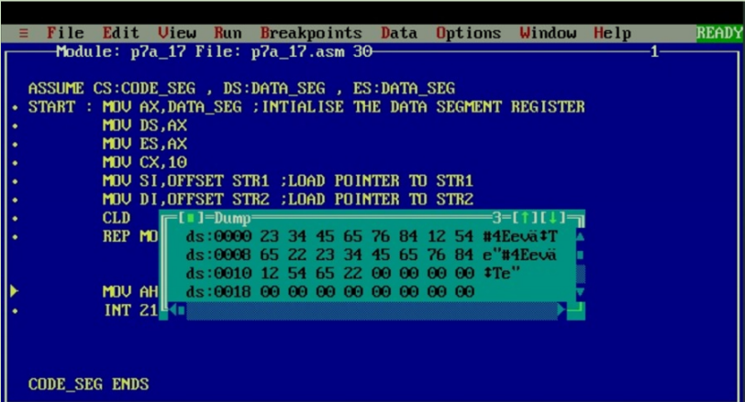

***Experiment 7(b) Title: Assembly language programming based on String operation.***

***Name of student: Meet Raut Class Roll Number: 2201084***

***Date of Performance: 01/04/2024***

***Batch: S2-1 Timing: 3:00-5:00 Date of Submission: 01/04/2024***

***Assembly language code***

*DATA_SEG SEGMENT*

*STR1 DB 23H,34H,45H,65H,76H,84H,12H,54H,65H,22H*

*DATA_SEG ENDS*

*CODE_SEG SEGMENT*

*ASSUME CS:CODE_SEG , DS:DATA_SEG , ES:DATA_SEG*

*START :*

*MOV AX,DATA_SEG #INTIALISE THE DATA SEGMENT REGISTER*

*MOV DS,AX*

*MOV ES,AX*

*MOV CX,10*

*MOV SI,OFFSET STR1 #LOAD POINTER TO STR1*

*ADD SI,9 #SI WILL POINT AT THE LAST INDEX*

*MOV DI,SI #DI WILL POINT AT THE LAST INDEX*

*ADD DI,5 #DI WILL POINT TO 5 INDEX AFTER LAST INDEX*

*STD*

*REP MOVSB*

*MOV AH,4CH #REQUEST TO TERMINATE*

*INT 21H #EXIT TO DOS*

*CODE_SEG ENDS*

*END START*

*Result:*

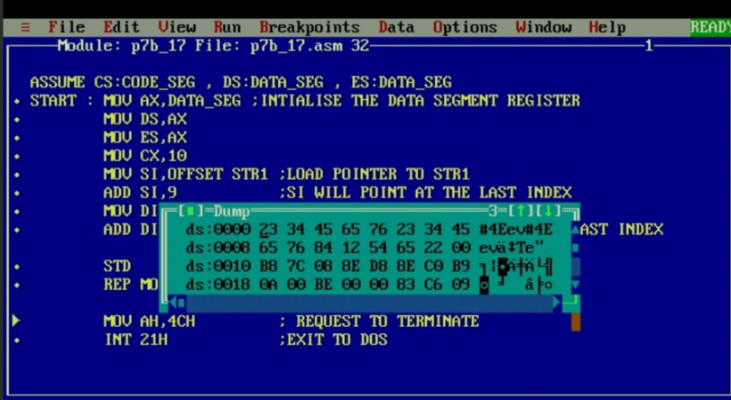

*CONCLUSION: LO 2, LO 3 mapped.*

***---------------------------------*****************************-----------------------------------***